**Instructions for using the microscope from Leica Microsystems**

1. Double check to see if the small silver USB drive labeled Leica (CmStick) is in the computer.
2. Move the camera to the microscope you are planning to use and make sure to replace the cap on the unused microscopes.
   1. Compound Microscope on the far left = LAXCO 3000
   2. Dissecting Microscope on the center left with Z-stacking capabilities = Leica M165C
      1. Lens options 0.5X and 1.0X
   3. Dissecting Microscope on the right = Leica MZ6; on a boom stand with drawing tube attachment. You may need to reattach the camera mount in order to take images if the drawing tube is on. Please see Dr. Ma for assistance.
      1. Lens options 0.32X, 0.5X, and 1.0X

**Please be very careful switching lenses! They are over $1,000 each. Use both hands and do not touch the lenses. Please see Dr. Ma if you need assistance switching between lenses.**

The instructions below are specific for the Leica M165C. If you are using one of the other microscopes there will be fewer steps and buttons to press.

1. The following four things should be turned on in this order.
   1. **The computer** (Login with your UT NetID and Password. Visitors and Volunteers please see Dr. Ma for the guest login and password.)
   2. **The microscope** (Leica M165C - the switch is on the lower back of the column)
   3. **The camera** (on/off switch located on the back of the camera).
      1. The light on the side needs to turn green. If the light remains orange, then check the back of the camera. The second switch should be set to PC. Not HD. Switch the toggle to PC and then the light should be green.
   4. **The light ring on the objective lenses**.

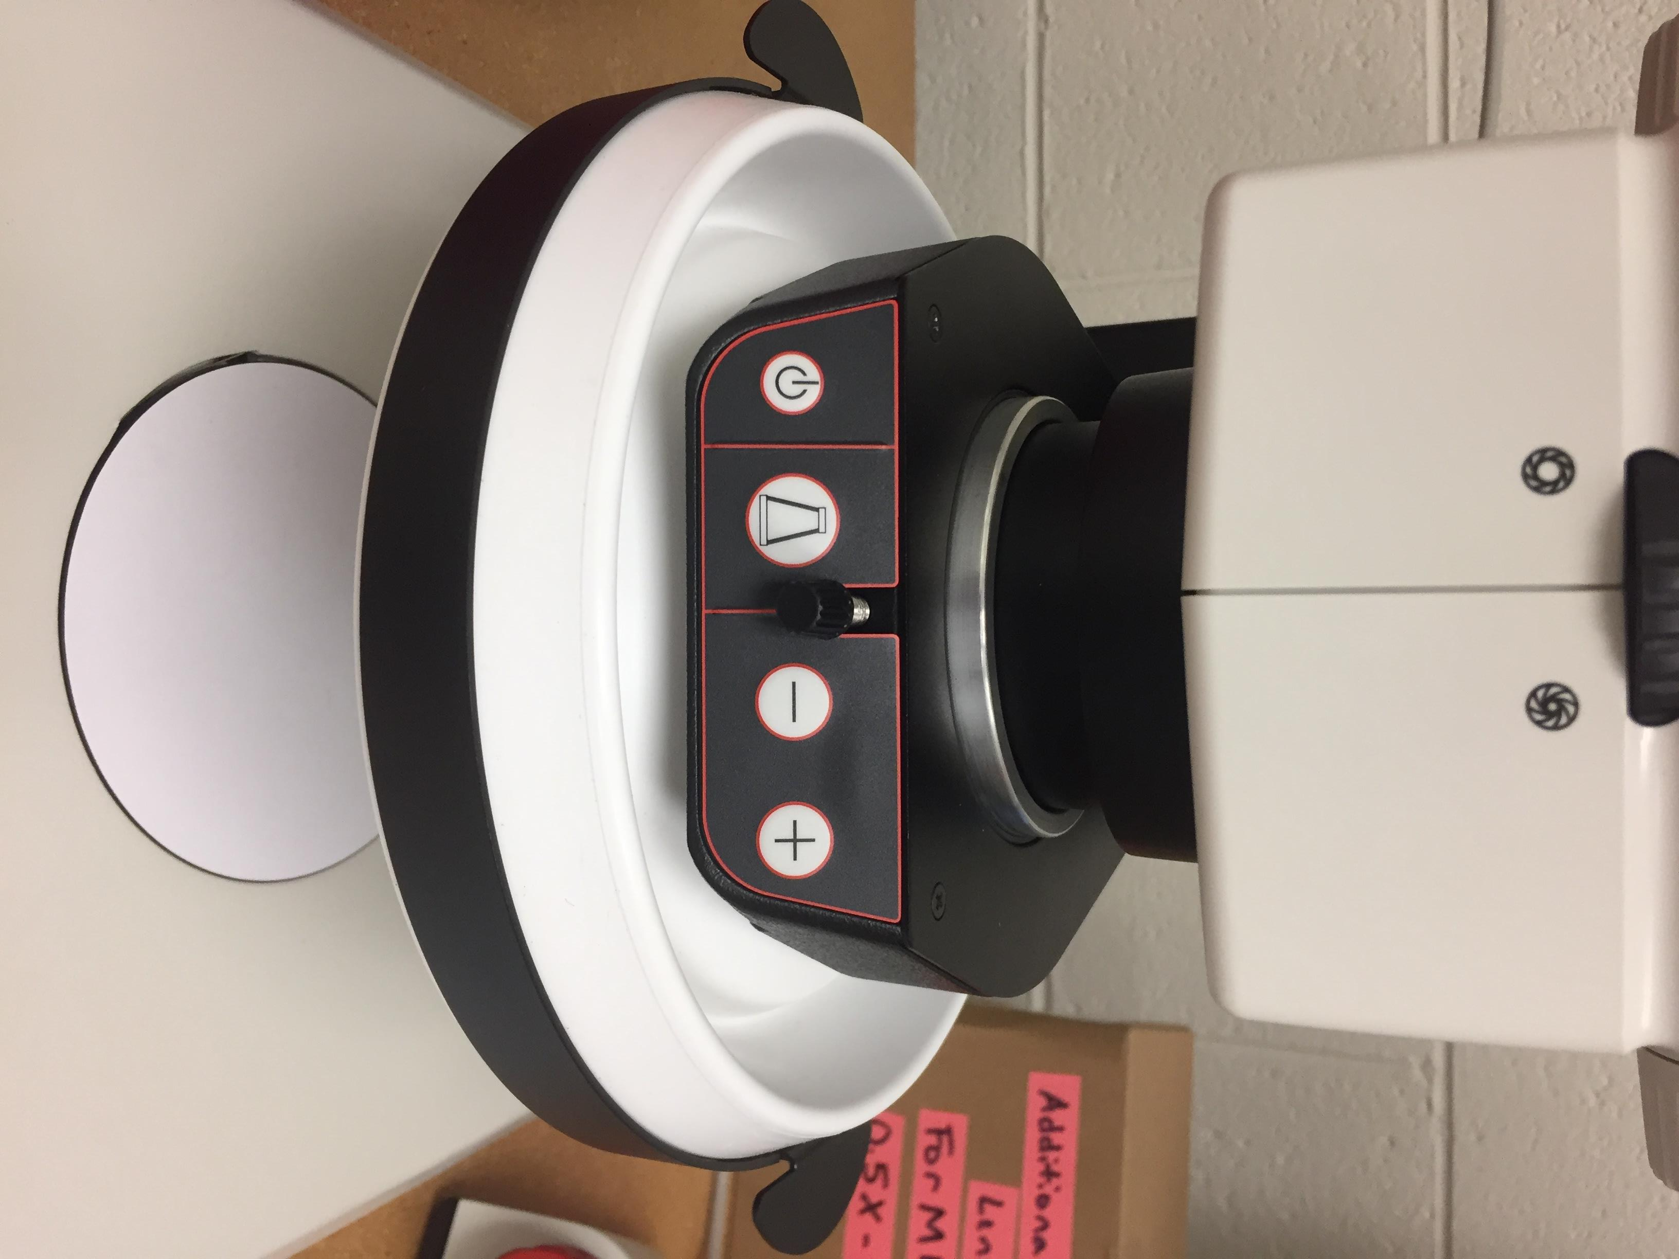

Increase/Decrease Light Intensity

Light Button: illuminates top light, bottom light, & both

Light Ring: On/Off Switch

1. Put your sample on stage plate in the center of the microscope base.
2. Focusing your sample.
   1. Shut off the path to the camera by pushing the metal bar located on the left side of the eye pieces in toward the microscope.
   2. Open the diaphragm by turning the black wheel, located on the front of the microscope, to the left.
   3. Turn the Focus Knob to the smallest reading (0.73).
   4. Press the **black button** (toggle: course/fine), then turn the **big**, **red knob** for Coarse/Fine focus.
3. Open the light path to the camera by pulling the metal bar (to the left of the eye pieces) all the way out.
4. Double click LASX icon on the desktop.
5. Be sure the Configuration is set to DefaultDynamicWideFieldTree.xlhw
6. Set Choose Configuration to the microscope you are using (Ex. Leica M165C).
7. Load settings at startup: OFF
8. Click OK



1. Z-Drive - Click No. (You did not adjust the clamps setting limits.)
2. Watch the loading screen and be sure that the microscope you selected scrolls by. If M125 scrolls through, this is an error. The microscope will need to be shut down and restarted.



1. Errors commonly occur at this stage. Shut down the program and restart. If that doesn’t work, then shut down the program, shut down the microscope, and restart.
2. The display should be in the Acquire tab with the screen displayed like this (the 1st image below), in Easy Operation Mode. If not, click on Configure tab, then Check the box to Activate Easy Operation Mode (the 2nd image below).





1. Click the Acquire tab, click on the **Live Image Arrow** at the bottom left edge of the screen to start live acquisition of your specimen.



Live Image play button

1. Now a live image of your specimen should be displayed on the screen.

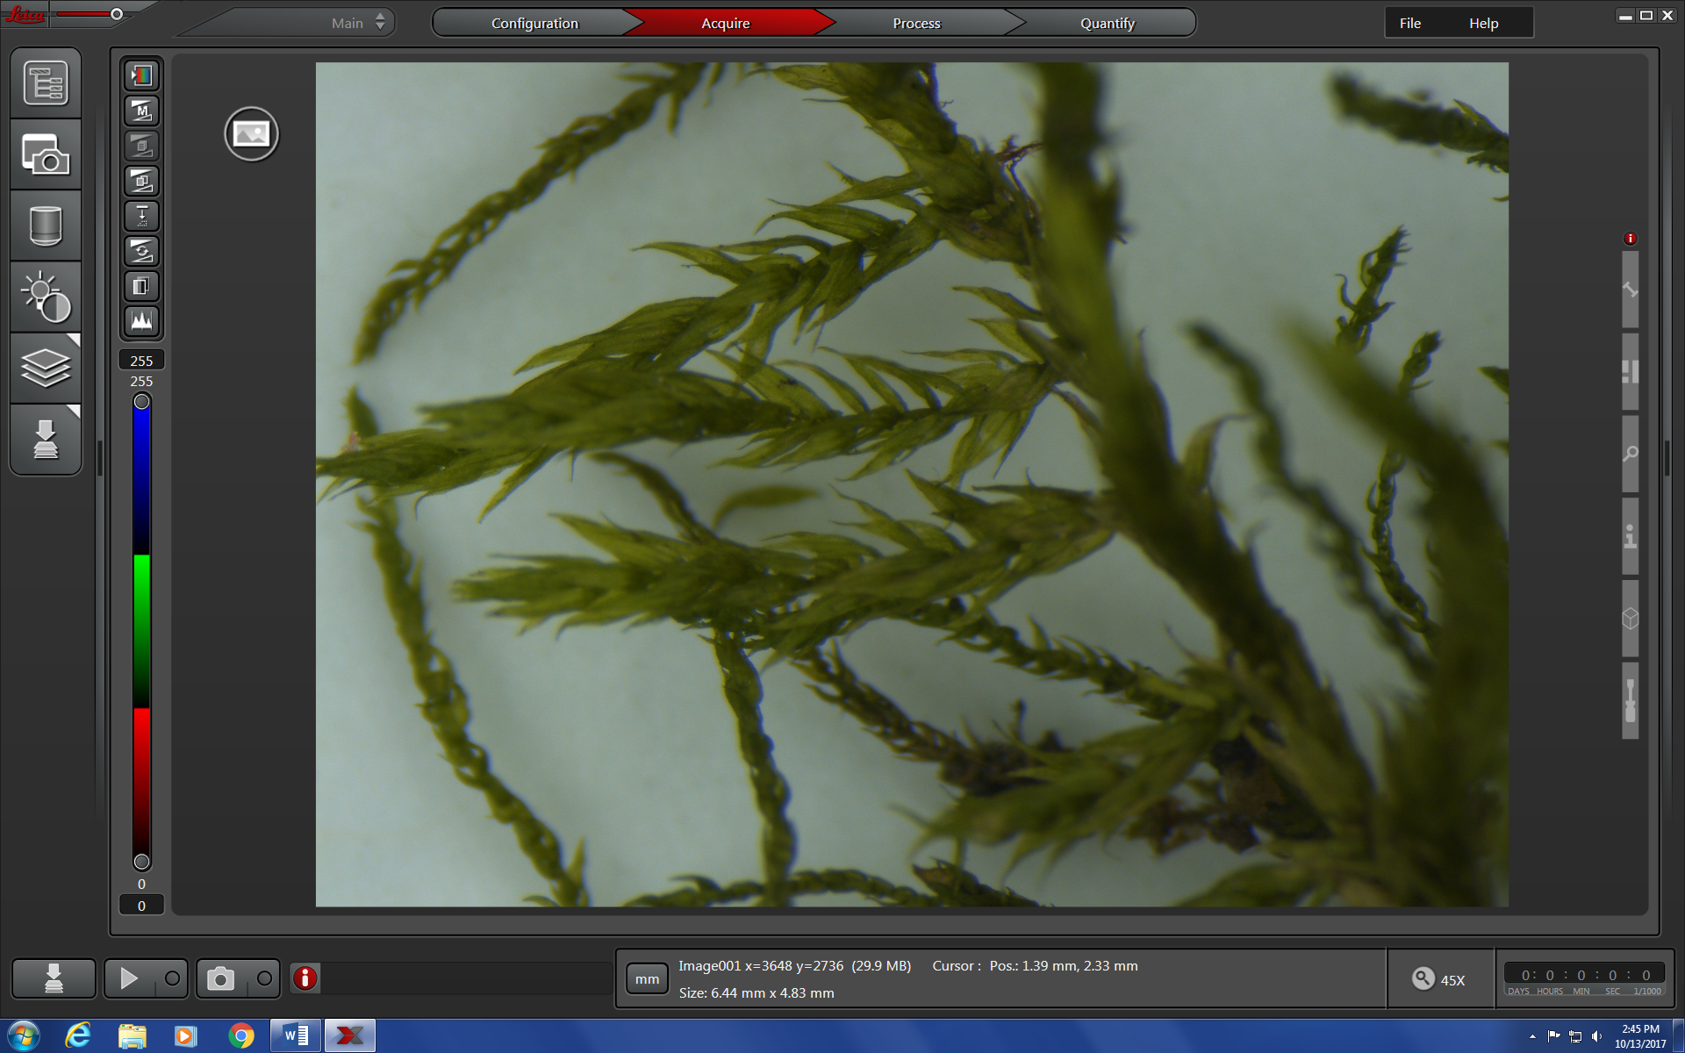

1. Setting the folder for saving your images.
   1. Click on the top left button (Explorer) that opens the **Open Project** menu.
   2. Click on the **Settings for next project** button.
   3. Give your project a name.
   4. Be sure **Auto-Save** is set to ON.
   5. Direct your images to be saved into the **Working folder** of your choice.
   6. You may also set a **User defined image name**.

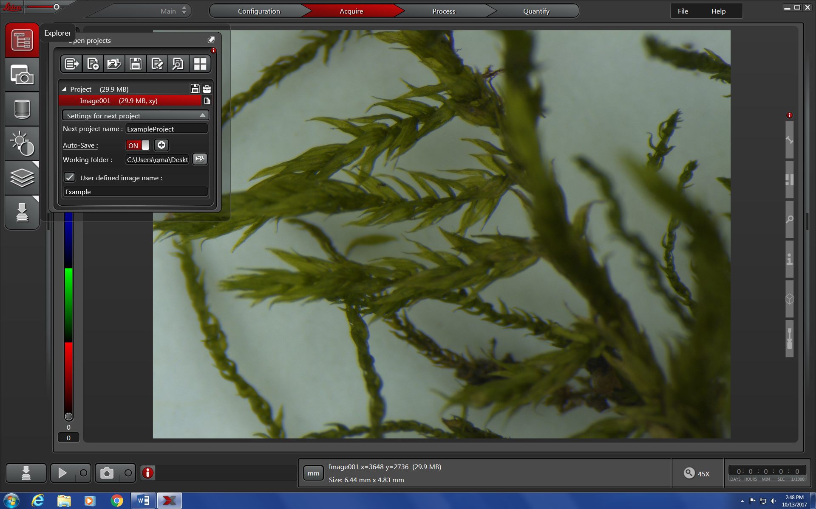

1. Making your images look good.
   1. Click on the **Image button** to open the pull out menu to adjust the image.
   2. Click on the **Auto exposure** button. It should stay red. (Under **Camera Preferences,** make sure that easy mode is turned off.)
      1. **Image Format:** 10.0MP
      2. **Live Format:** 1.9MP
      3. **Color Mode** - Checked
      4. **Camera Profile:** new*
   3. If the colors or background whiteness is off then follow the instructions below.
      1. Click on the **Show/Hide Color Controls** button.
      2. Use the color controls, saturation, and **White Balance** button to adjust the colors until your specimen looks realistic. You can use the **White Balance** with the specimen in place or only a white background. If the light is too intense you will get an error message. You can always use the **Reset** button to go back to the original colors.

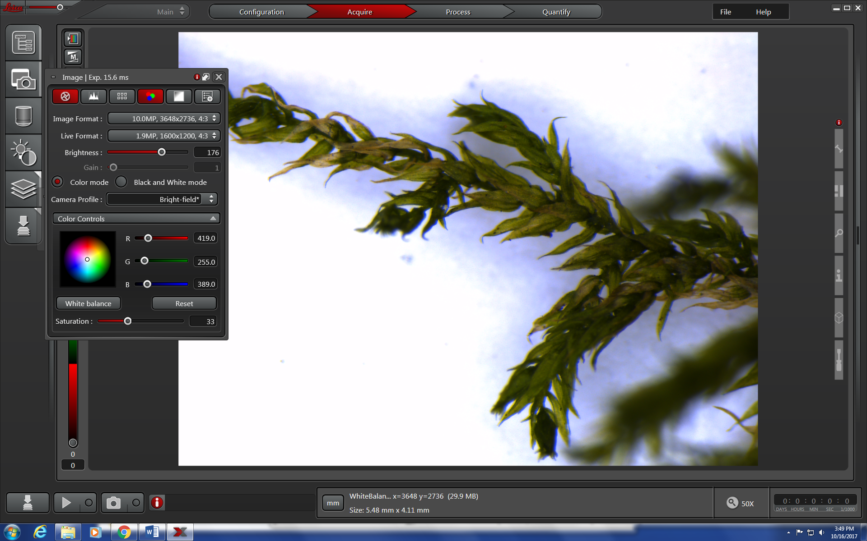

1. To add a Scalebar, hover over the top expandable tab on the right side of the screen and click **Scalebar.**
   1. **You can modify all aspects of the scale bar in this menu.**

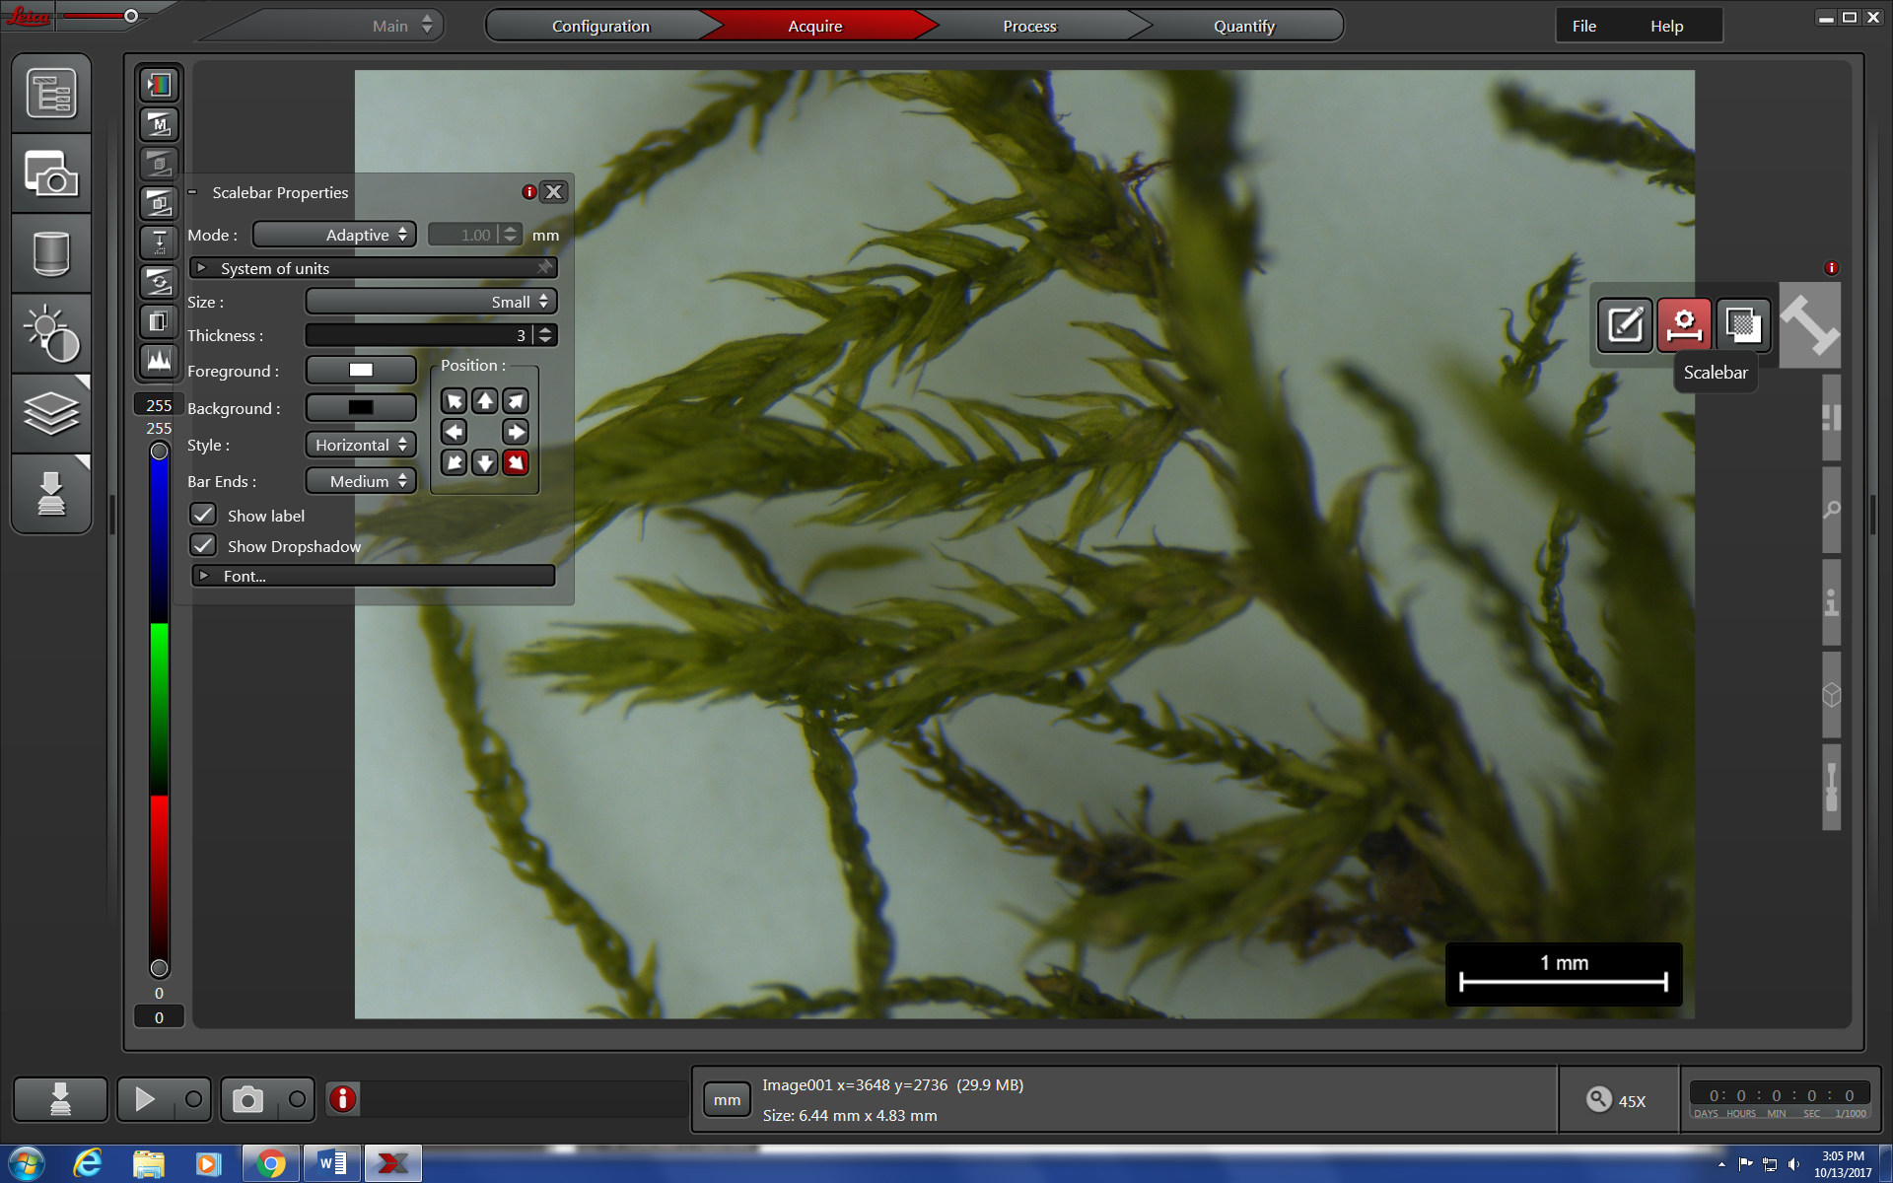

1. Click **Capture Single Image** to acquire photo under your active project folder.
   1. Do not touch the table while the camera is taking the images. Any vibrations will make your images blurry.

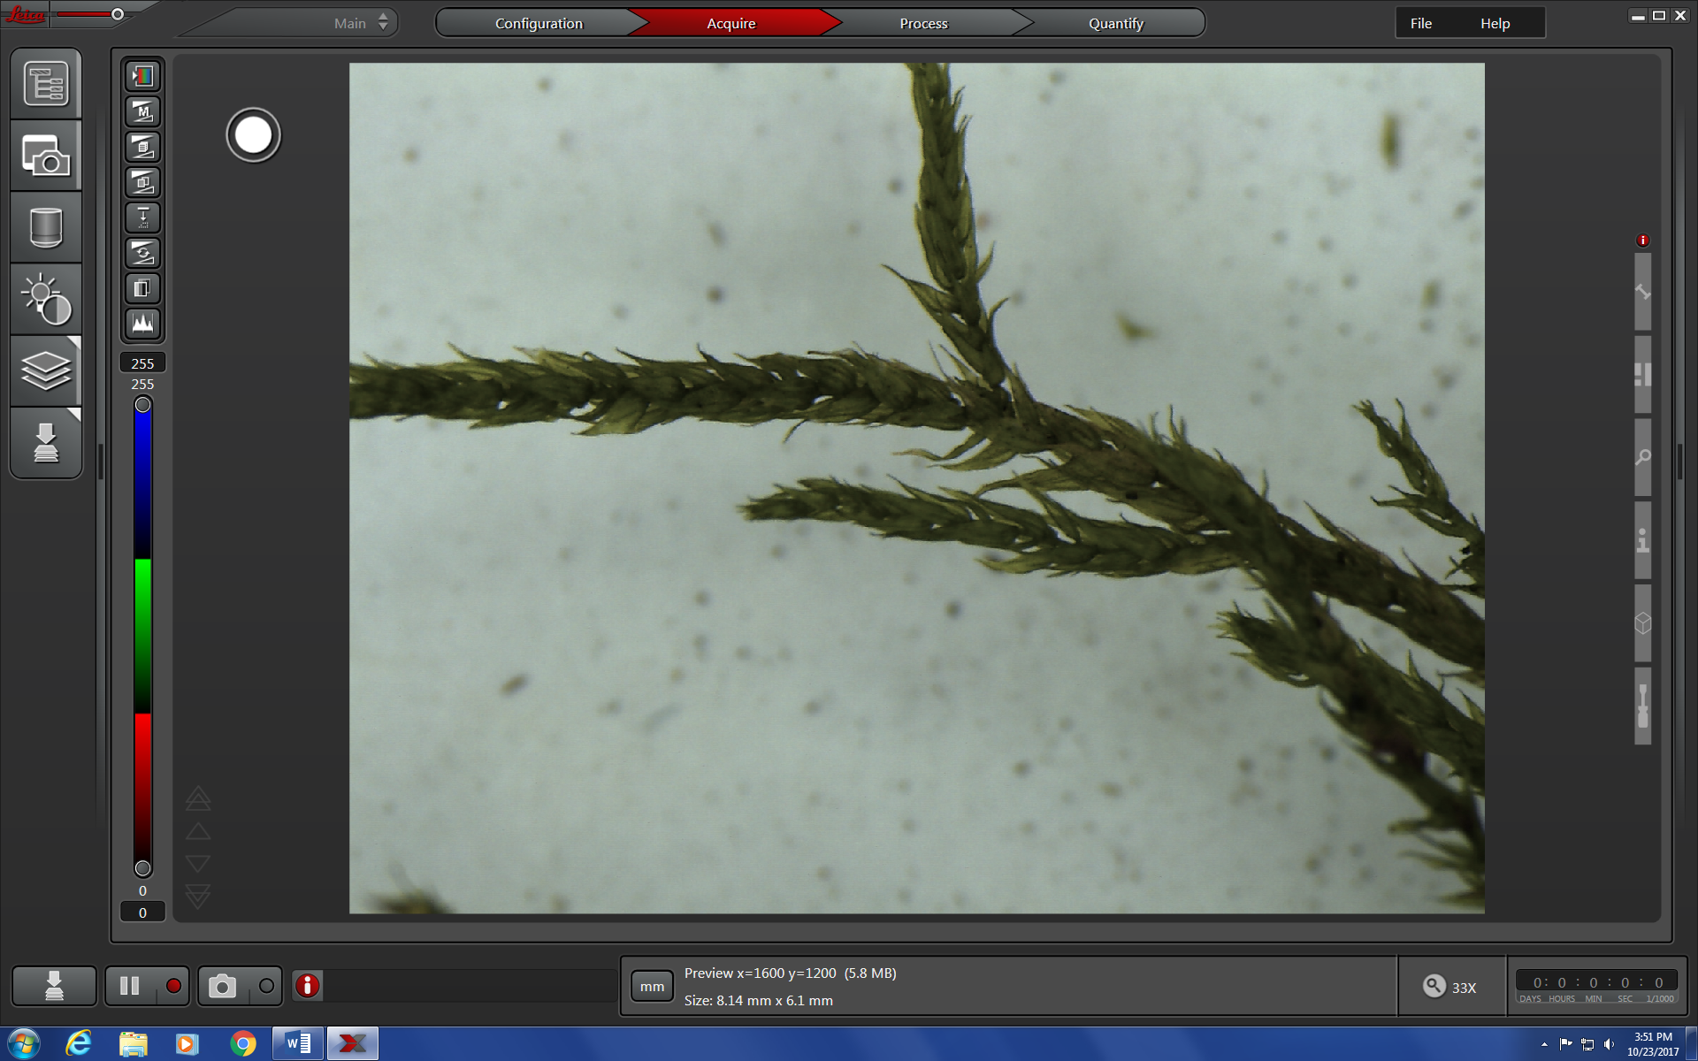

**Capture Single Image** button

1. Save these images as TIFFs by right clicking on the entire project title (e.g Ma1) and export as Tiff.

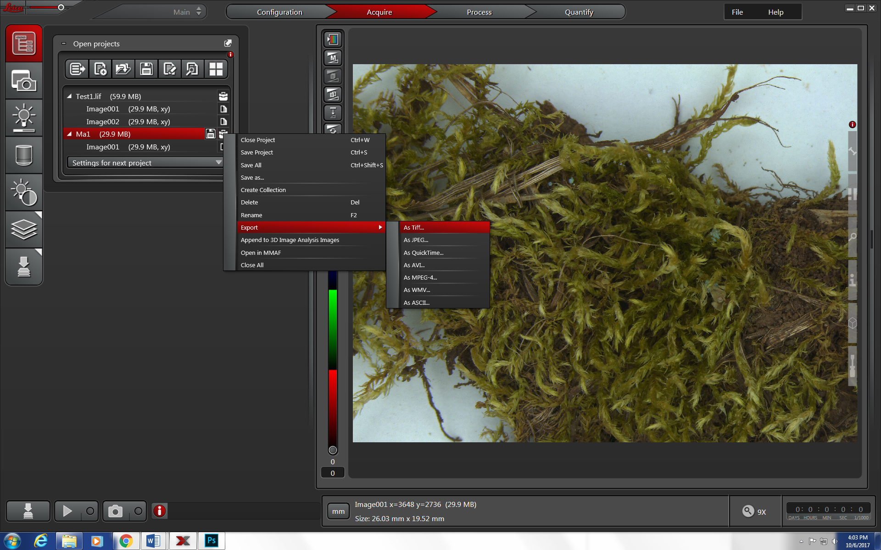

1. When exporting, make sure to check: Overlay channels, Lossless data compression, Use Directories, and then check the desired destination folder. By default, it will be set to your working folder.

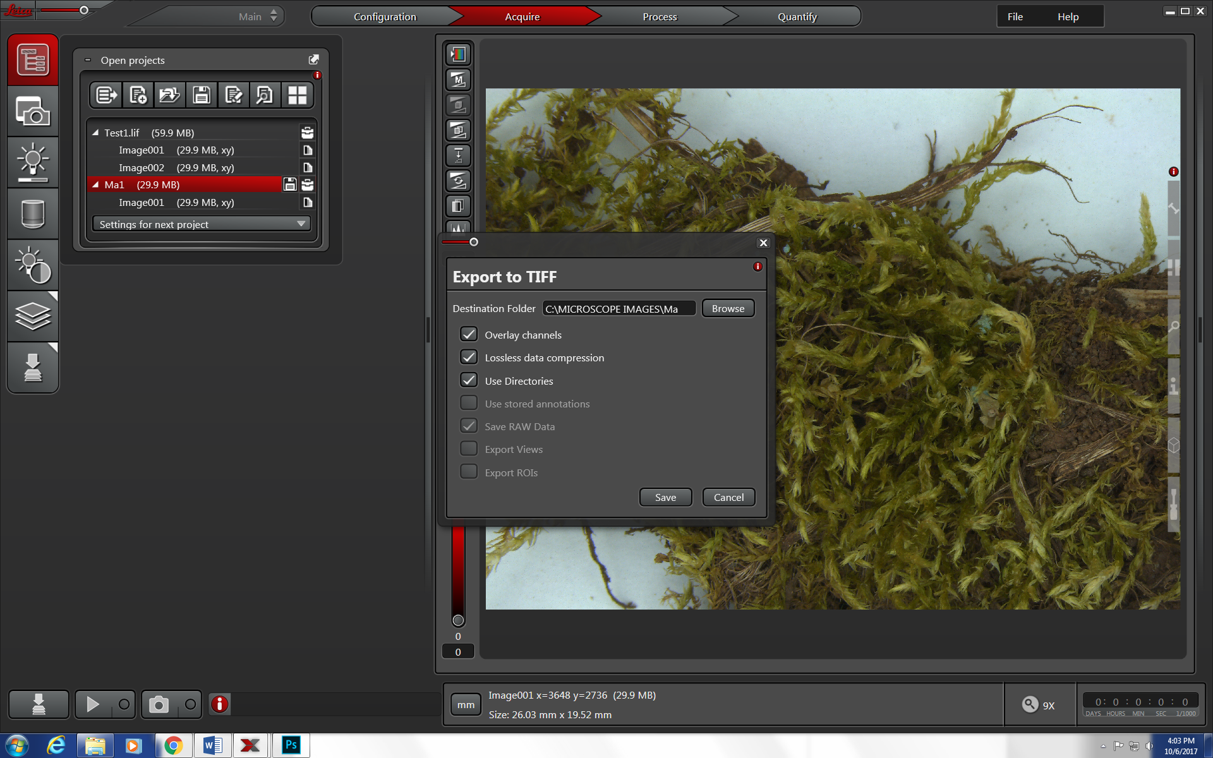

**Z-Stacking**

The idea here is to take multiple images of your specimen at different focal depths and then merge them into a single image so that your specimen is in focus, from the top to the bottom

1. Click on the **Z-stack** button
   1. Click **Custom**.
   2. Use the large red focusing wheel to focus to the top of your specimen and then a bit farther until it is slightly out of focus.
   3. Click **Begin** to set the top position for the photos.
   4. Then use the large red focusing wheel to focus to the bottom of your specimen and then a bit farther until it is slightly out of focus.
   5. Click **End** to set the bottom position for the photos.
   6. Check to be sure the **System Optimized** button is checked. The **Nr. of Steps** will tell you how many images the computer is planning to take. If this number is very large then it will take the microscope a long time to take all the images. If the number is too big, then check the **Nr. of Steps** button and adjust the number to a manageable size that will optimize your time spent on the microscope, so that you do not have to wait as long, but the more images in the stack, the higher the quality will be. The **Z-Step Size [um]** tells you how much distance there will be between each photo.

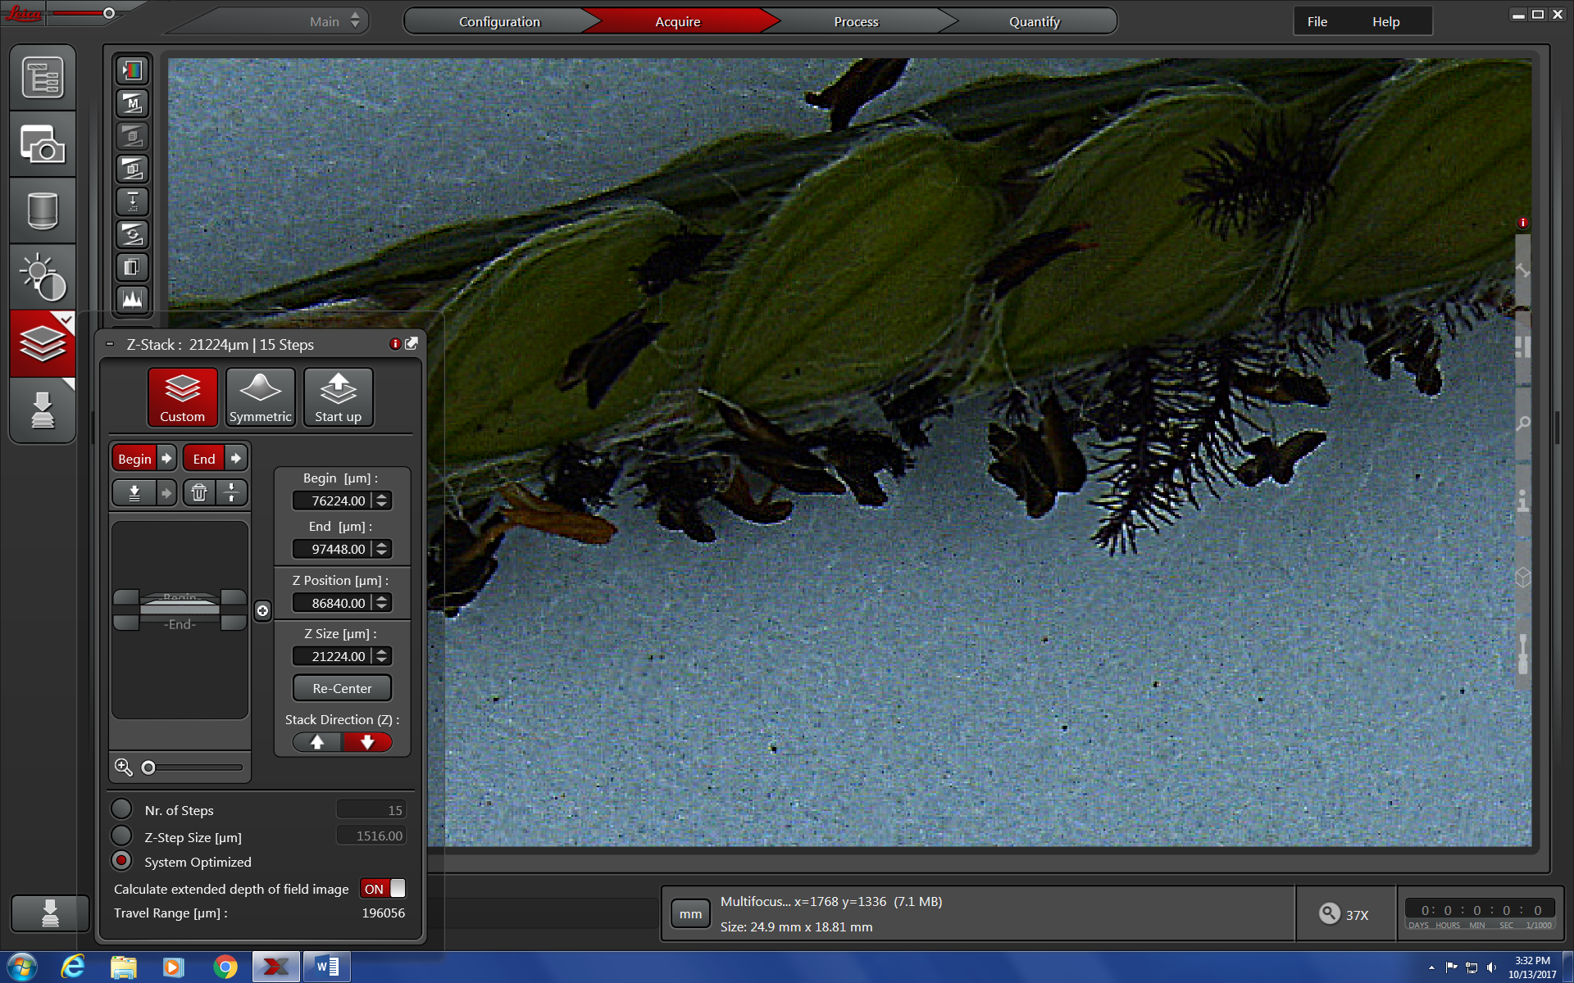

* 1. Click the **Start Experiment** button to start taking z-stacked images of your specimen. Do not touch the table while the camera is taking the images. Any vibrations will make your images blurry.

**Start Experiment** button

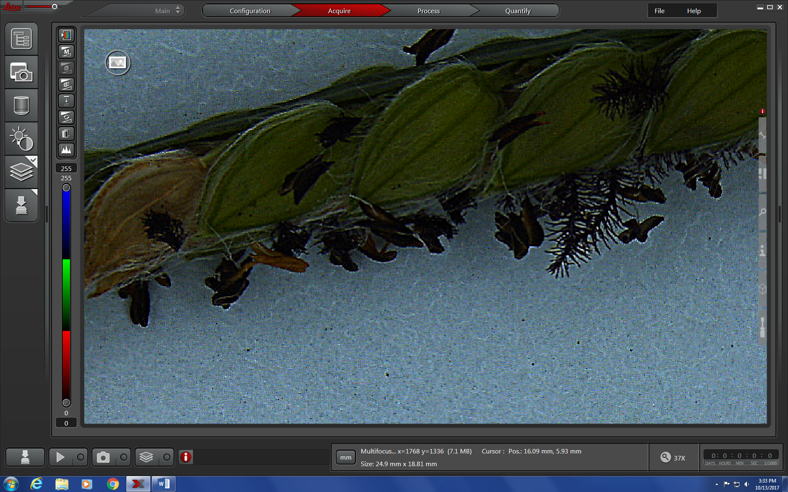

1. Z-stacked images are saved in the same manner as individual images. See instructions #18 & #22-23 above.
2. Remember to exit the Leica microscope software when finished!!
3. Log off the computer when you are done. Do not shut down the computer. It should go to a blue screen with **CTRL + ALT + DELETE** on the screen.